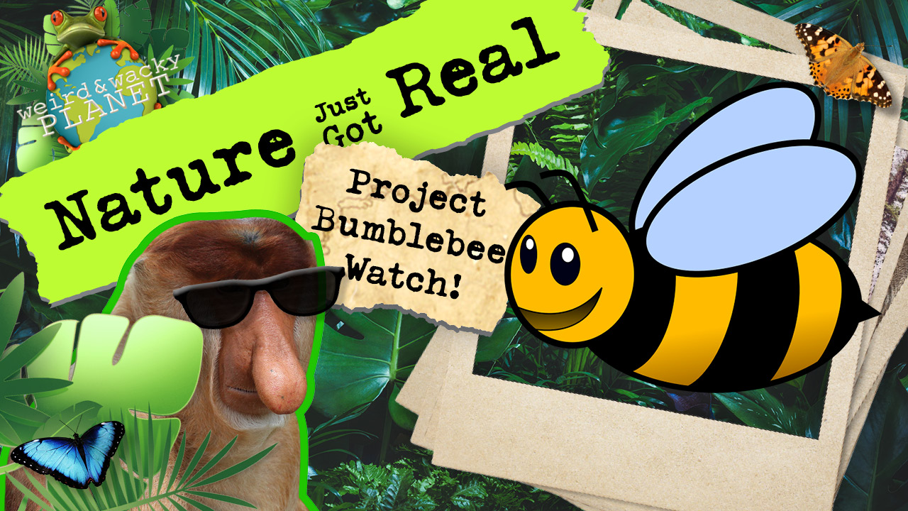

How to Participate in Project Bumblebee Watch:

Gather your materials. You will need:

- A Camera, a Video Camera, or a Smartphone
- The Bumblebee Watch app for IPhone or Android OR you can also upload your picture directly to the website at Bumblebeewatch.org
- A Field Notebook if you want to document your findings (you know I like THIS idea)

The first step is to find a Bumblebee. Rich Hatfield of the Xerces Society recommends using a video camera and then taking your still photographs from there, since it’s easier to capture close-ups from a safe distance. We don’t want the Bumblebees to feel threatened or make them feel anxious. I like this idea a lot and will be trying this.

The key here is to keep a safe distance. From Captain Jack’s investigation, we already know that Bumblebees can sting, but rarely do so, unless threatened. We want both ourselves and the Bumblebees to feel safe. Remember, if a Bumblebee approaches you, don’t swat at it. Just be still or back away slowly. It will lose interest when it figures out you aren’t a flower!

If you are allergic to bee stings, you can still participate. Just have someone else do the filming or picture-taking. You can do the documenting and upload the images.

Next, use the app or the website to identify your Bumblebee species, upload your image and the details it asks for, and you’re done. You just helped the Xerces Society, IUCN, and Scientists track the Bumblebee species in your area. Good job!

Go have a Bumblebee Tracking Science Adventure in YOUR backyard!

